POM

Innovation attributes on 3P Object - Map’s evolution

Change request: R231018_000022 ​

Functional & Technical Specifications

|  |  |  |  |
| --- | --- | --- | --- |
| Version | Description | Author | Date |
| v0-1 | Draft | Christelle Zalisz | 16/11/2023 |
| V1-0  V1-1 | Initial  Modified | Eric Coopman  Christelle Zalisz | 12/12/2023  14/12/2023 |
|  |  |  |  |
|  |  |  |  |
|  |  |  |  |
|  |  |  |  |

# Functional requirements

## Business needs – PIM configuration

The Roquette Innovation process is led by Marc Ravon, Head of customer Innovation. The purpose of this process is to launch Roquette innovating product on the market.

When a product is launched on the market, the time to reach profitability is 5 years.

As today, there is no product attribute to support the innovation product launched on market and follow up the sales activities in Salesforce.

All follow up is made on excel file by the innovation team.

Innovation attributes have been configurated in PIM to support this process on 3P object in Marketing class attributes.

Marketers are in charge of contributing to this information when a new product from innovation process is integrated in PIM.

To ensure the flow to Salesforce :

Bolean tag Inno : per default value No

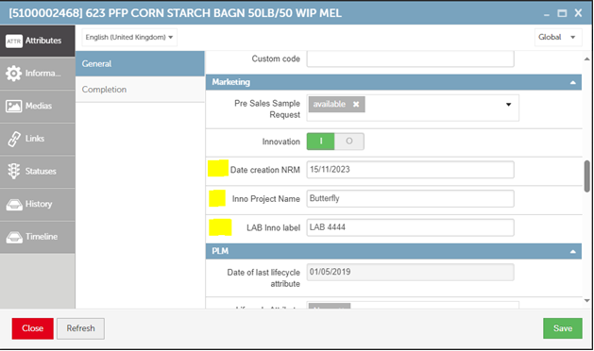

A full data initialization will be provided by the business.

## Innovation tag display in CPSO:

In order to inform Sales about products from the Innovation process, a tag Inno will be displayed on CPSO product page list and product page.

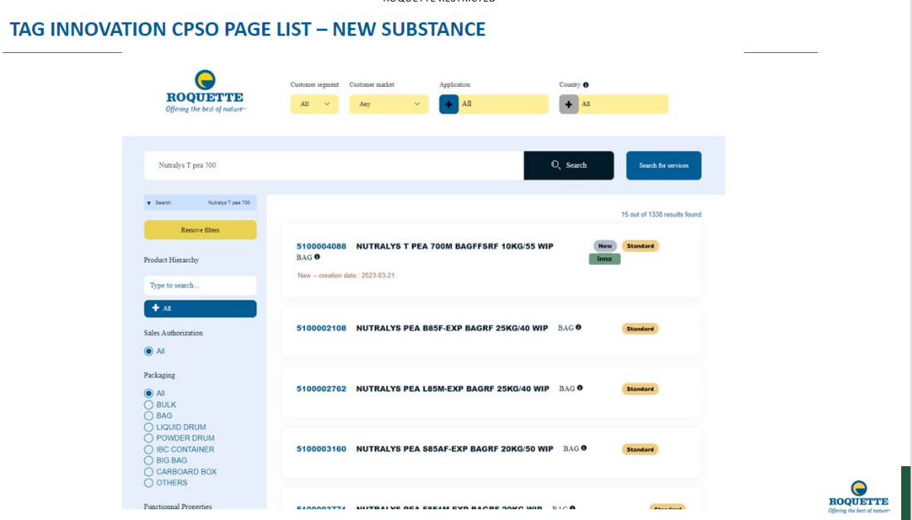

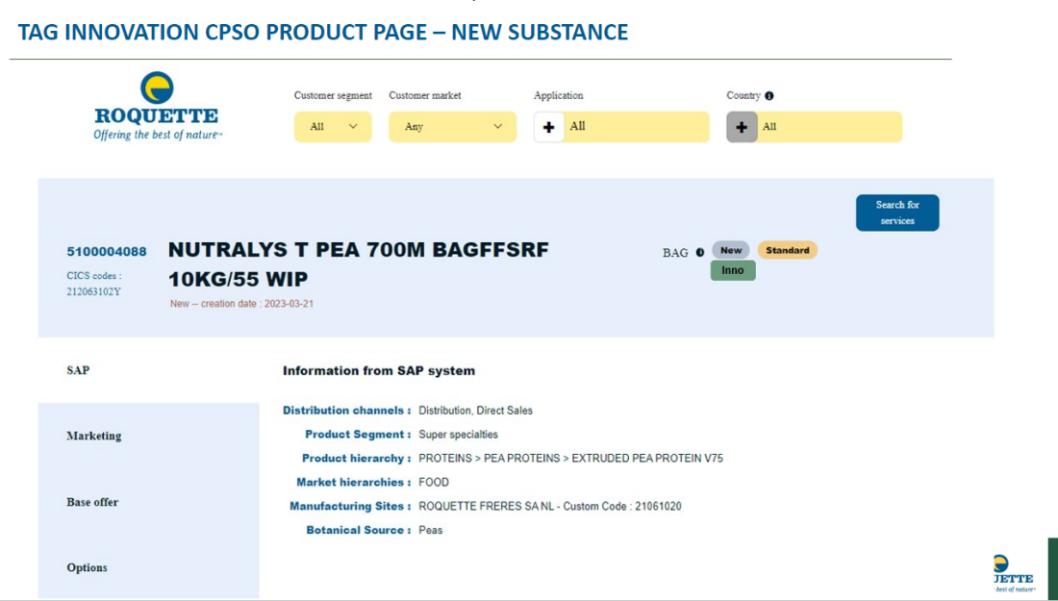

This CPSO update will be conducted by Map’s integrator Clever Age.

## Innovation attributes added to Map’s- Salesforce product flow

In Map’s – Salesforce product flow, add the 3P Innovation attributes.

Pre requisite : Innovation attributes field configured in Salesforce product.

# Impact & Modification

# Technical Specifications

We add in the extraction product flow from Maps System to Salesforce 4 fields for the 3P object (HierarchyLevel__c = 3P):

* Is_Innovation__c (Innovation)
* NRMCreationDate__c (Date creation NRM)
* InnoProjectName__c (Inno Project Name)
* LabInnoLabel__c (LAB Inno label)

Innovation field is a Boolean in Maps System. It means 3 values: True, False, Null…

On Salesforce side, we have only 2 values.

Talend will transform Null to False when inserting in Salesforce.